13.02.2025 5:22

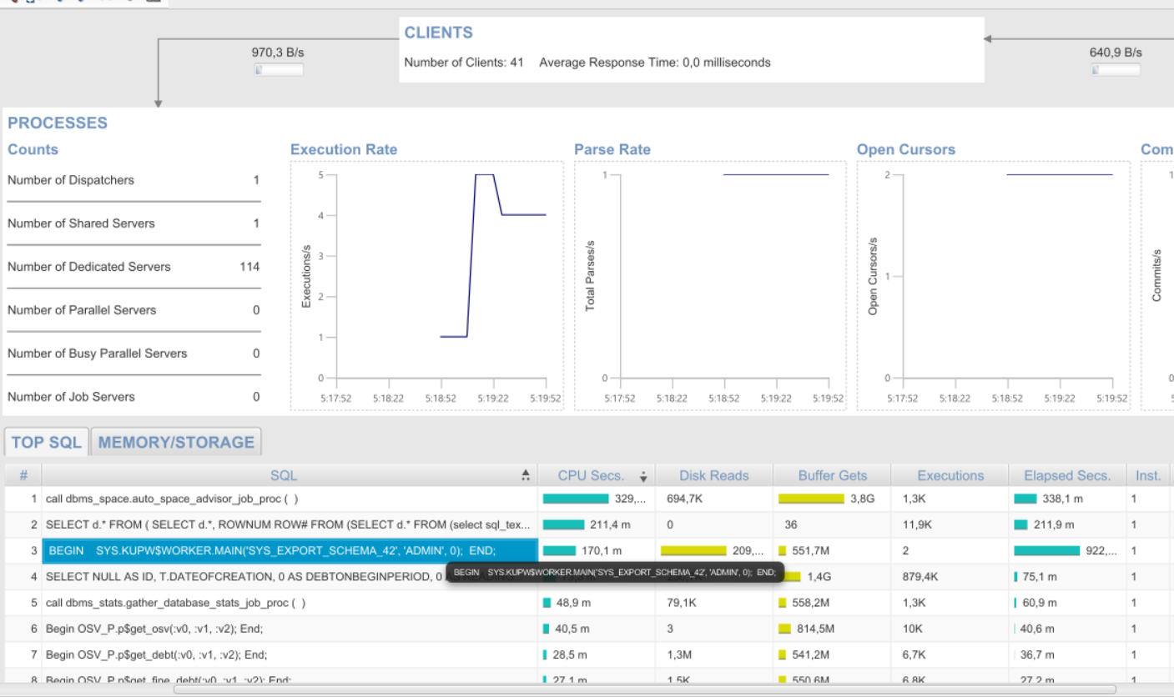

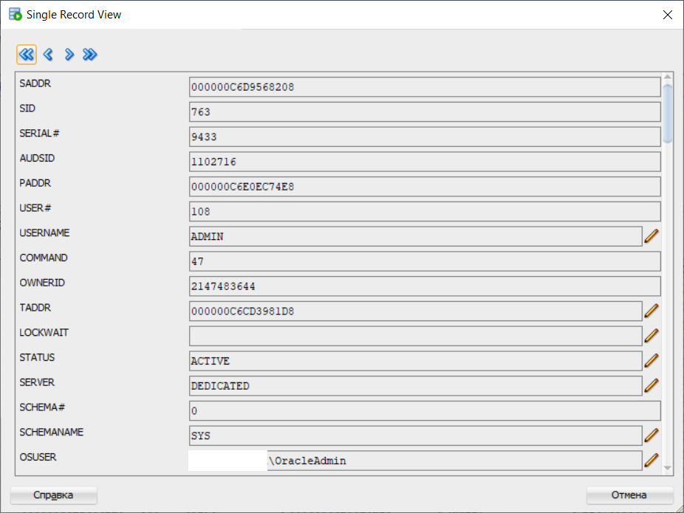

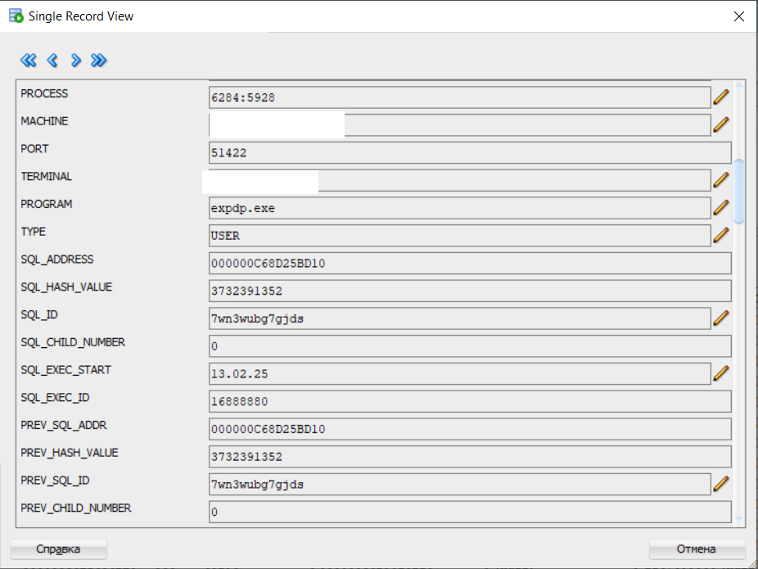

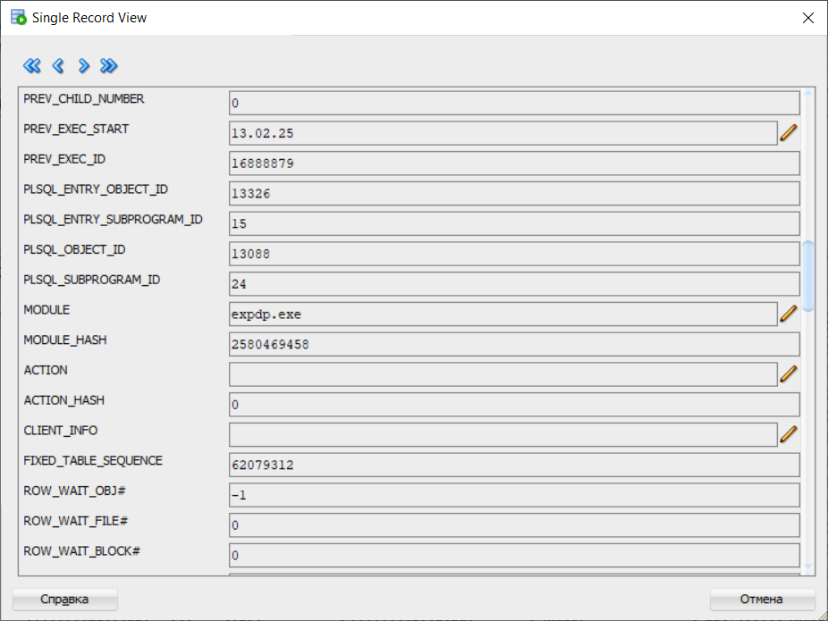

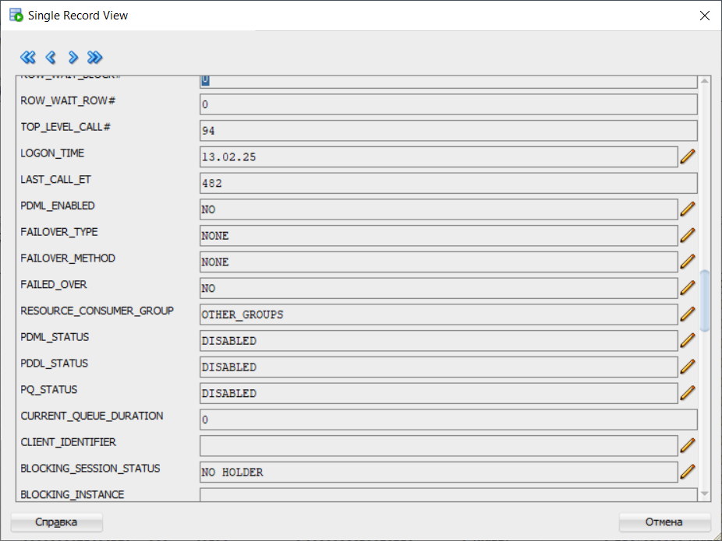

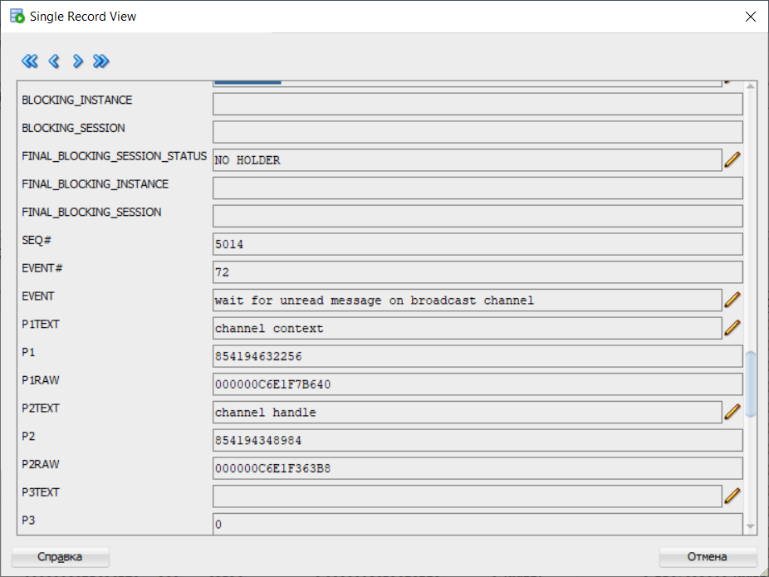

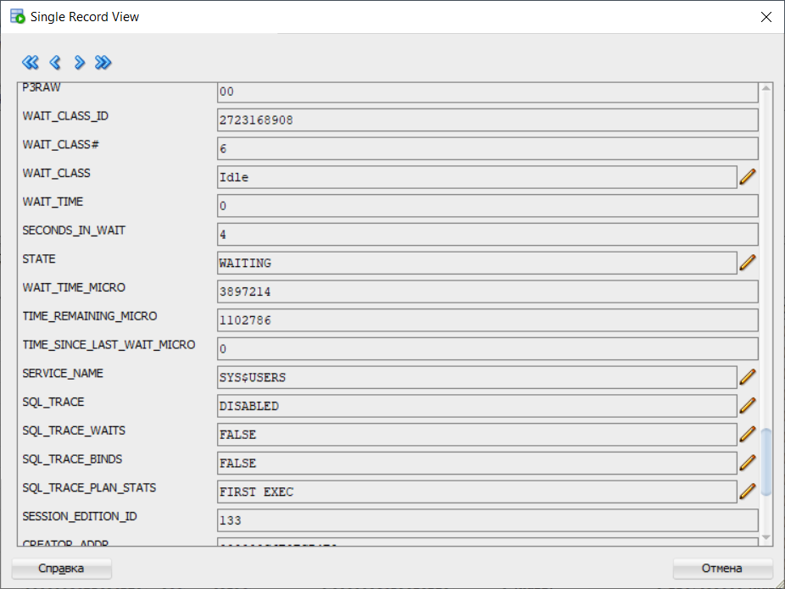

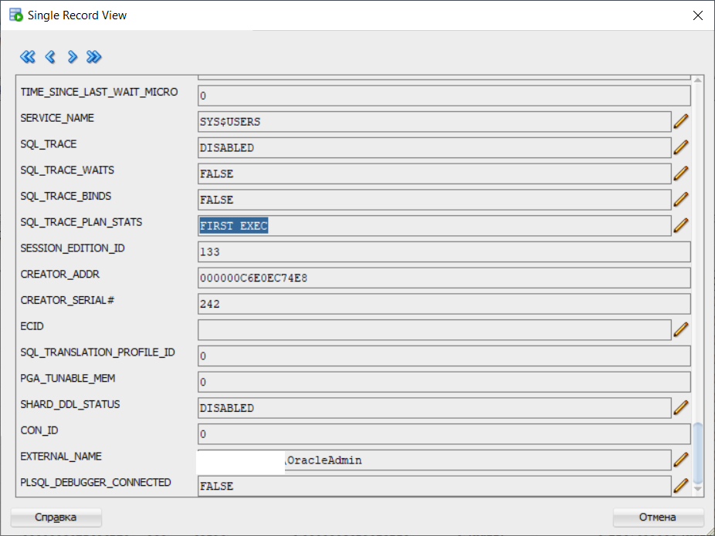

SELECT

s.sid,

s.serial#,

s.username,

s.program,

s.status,

s.machine,

s.osuser,

s.module,

s.action,

s.event,

s.wait_time,

s.seconds_in_wait

FROM

v$session s

WHERE

s.program LIKE '%expdp%'

ORDER BY s.sid;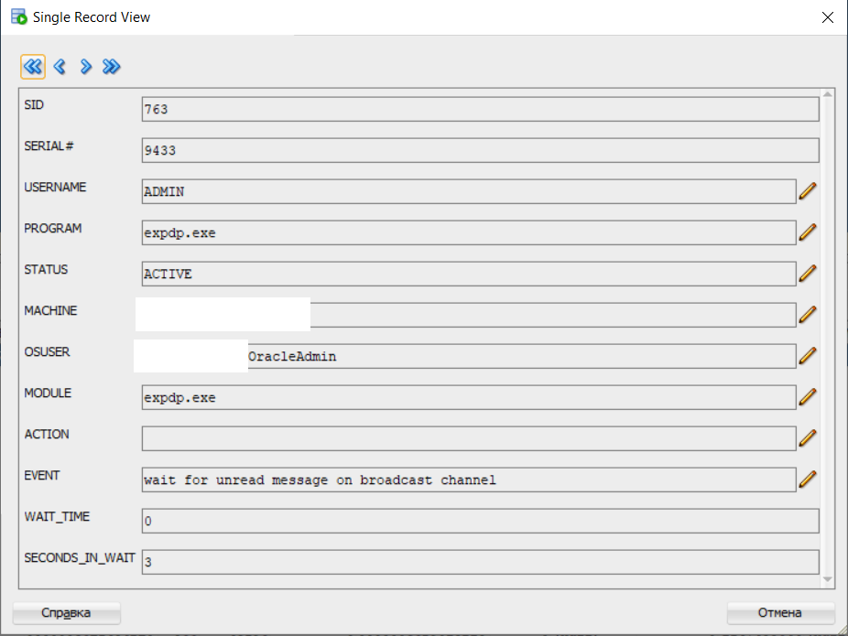

SELECT

job_name,

operation,

state,

attached_sess,

owner_name

FROM

dba_datapump_jobs

WHERE

state IN ('EXECUTING', 'WAITING')

ORDER BY

job_name;

