13.02.2025 5:22
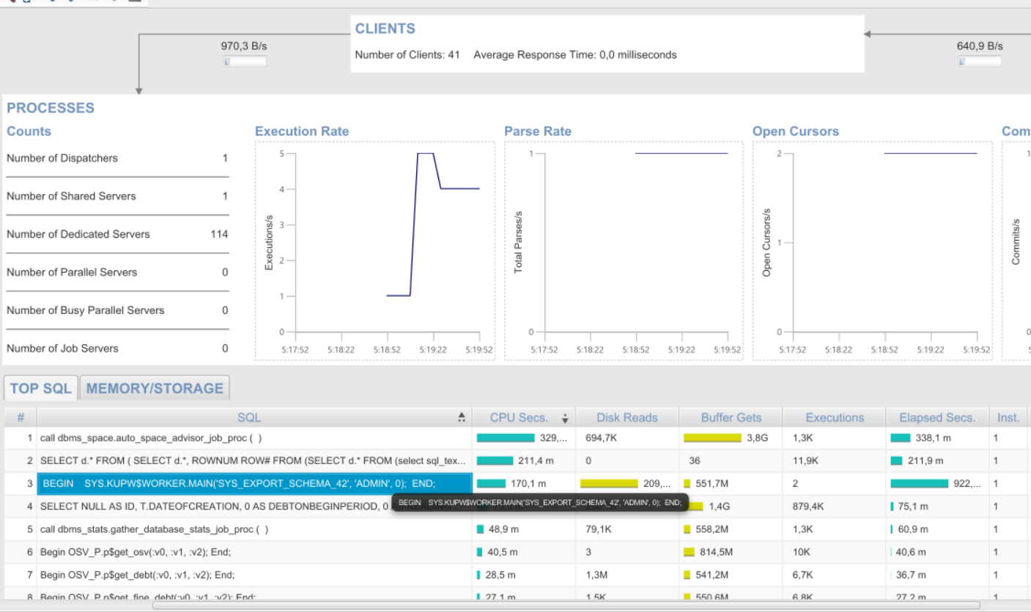
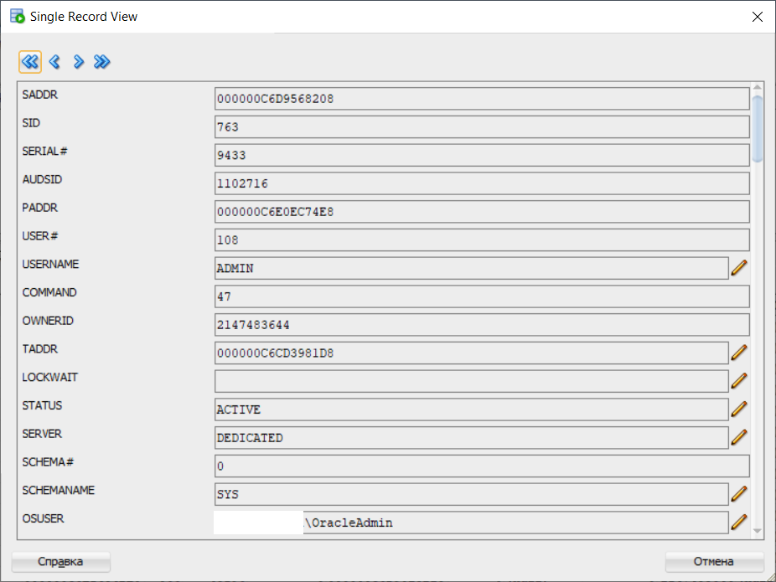
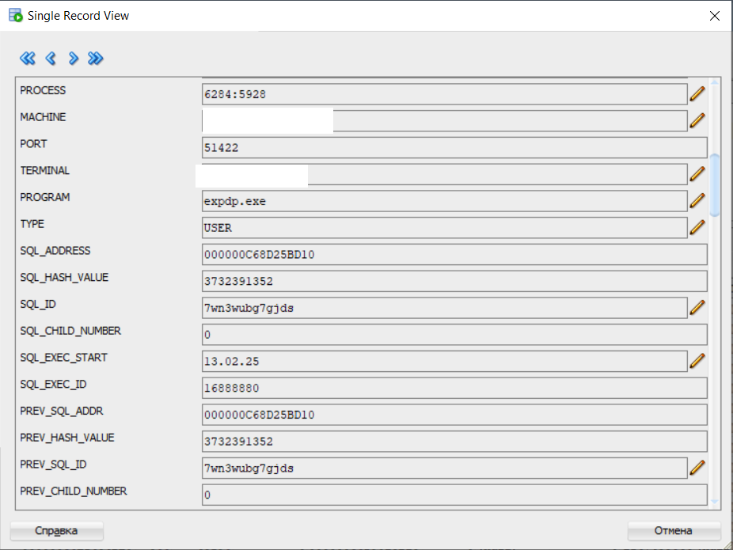
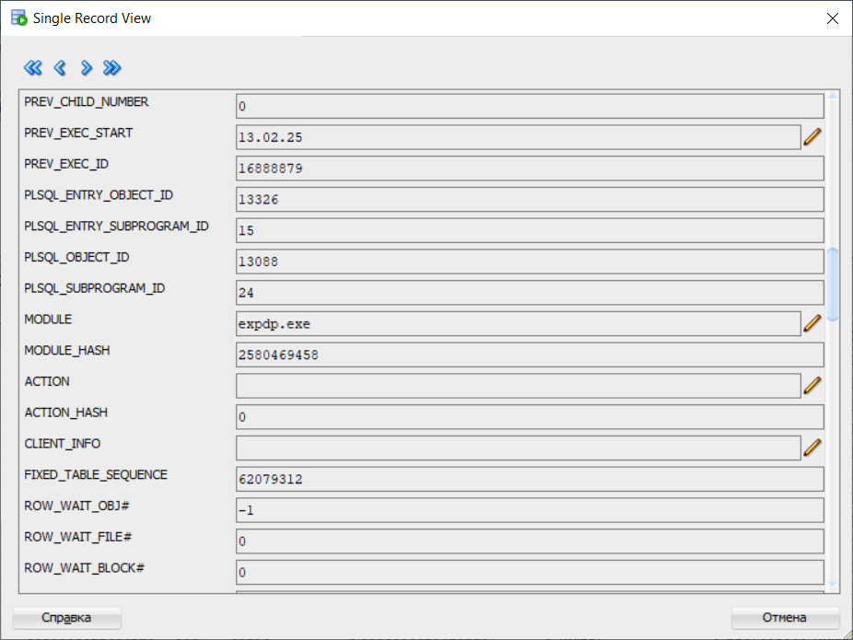
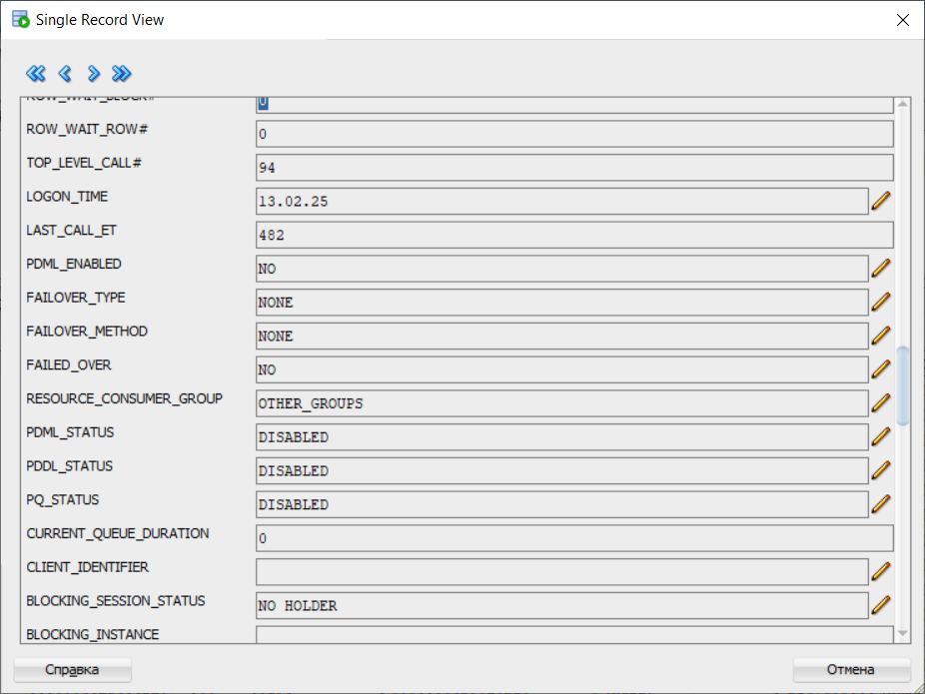
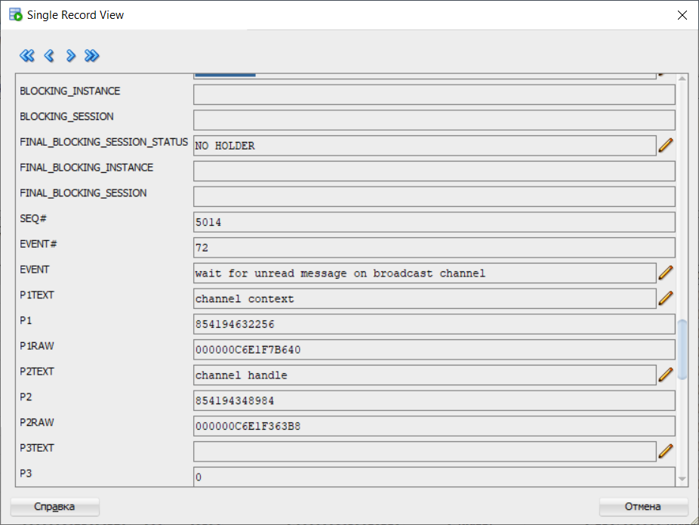
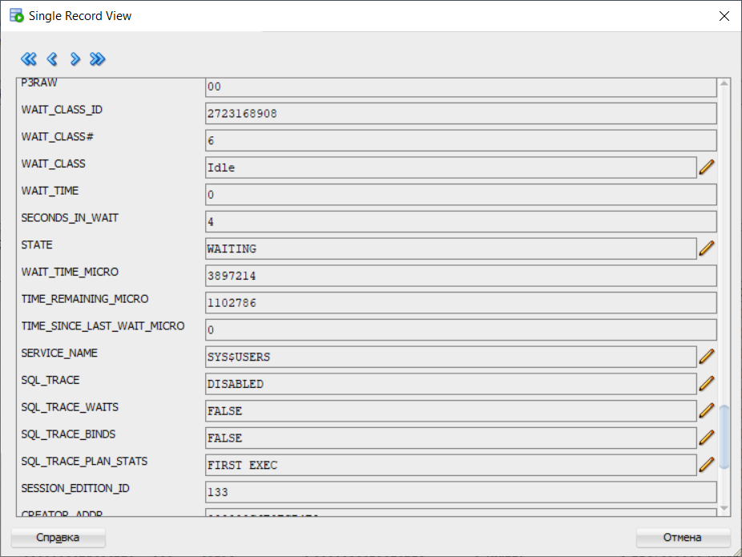
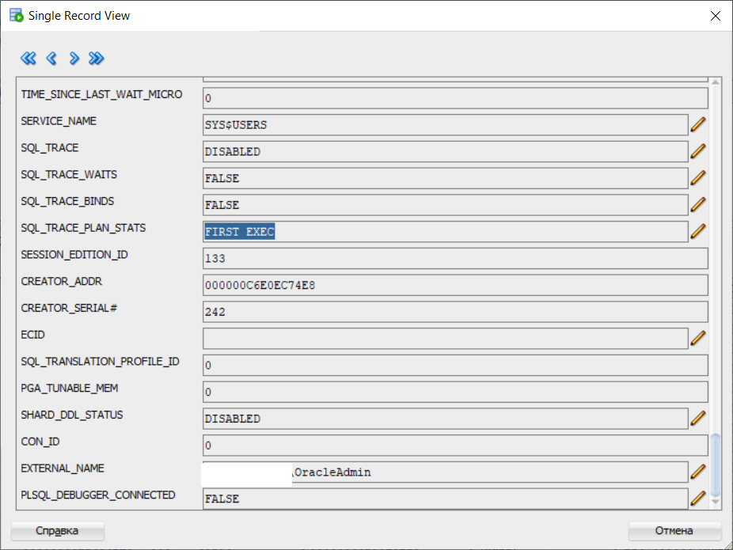
SELECT
s.sid,
s.serial#,
s.username,
s.program,
s.status,
s.machine,
s.osuser,
s.module,
s.action,
s.event,
s.wait_time,
s.seconds_in_wait
FROM
v$session s
WHERE
s.program LIKE '%expdp%'
ORDER BY s.sid;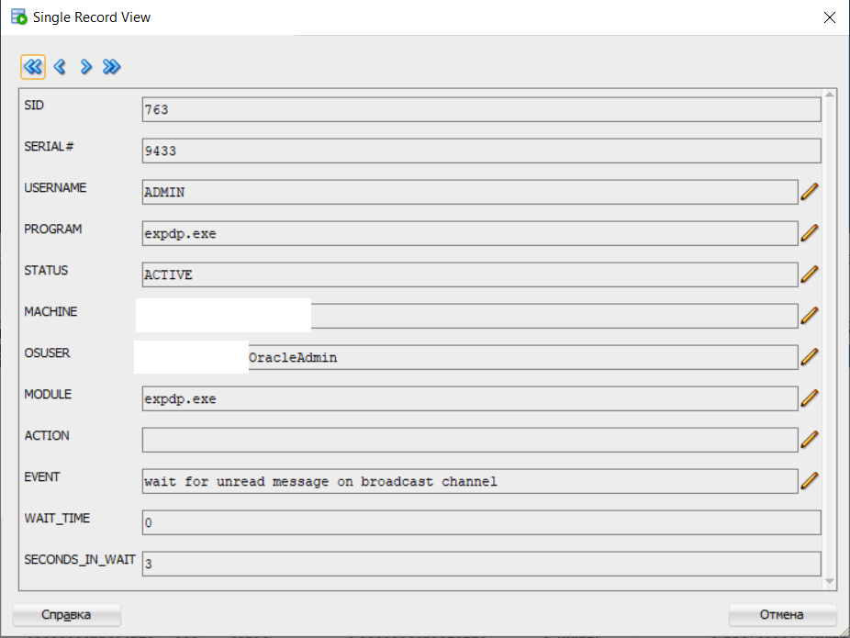

SELECT
job_name,
operation,
state,
attached_sess,
owner_name
FROM
dba_datapump_jobs
WHERE
state IN ('EXECUTING', 'WAITING')
ORDER BY
job_name;
